CECIL ANDREWS COLLeGE

ATAR Human Biological Science Unit 4

Science Inquiry 4: Human Evolution

Answers

**Part A: At home**

Prepare notes to the two questions on the next page and you may use any available resource available to you.

**Part B: In-Class**

You need to study your notes to enable you to complete the in-class validation test that will include TWO extended response questions. These questions will be based on your take-home questions, but will **NOT** be your take-home questions. You will have 20 min to write your answer.

***IMPORTANT: NO NOTES will be allowed during the in-class validation test***

**In class validation**

**Answer all questions**

1. A near-complete fossil skeleton was recently discovered in the Olduvai region of East Africa. Initial anatomical analyses suggest that the fossilised skeleton is that of a *Homo habilis*. This identification is further supported by its dating to 1.8 million years before present.
   1. Describe the likely anatomical features of the fossilised skeleton that lead to the conclusion it was *Homo habilis* and not some other species. (5 marks)
   2. Tools consistent with Homo habilis were also found in the vicinity of the fossilized skeleton. Describe the tool culture associated with *Homo habilis*; include in your answer what these tools may have looked like and how their use reflected the lifestyle assumed for *Homo habilis*. (5 marks)
2. Discuss how tools subsequently changed with the emergence of *Homo erectus* and *Homo neaderthalensis*. (10 marks)

**Research Answers**

1. Cultural evolution: During the biological evolution of hominins from the earliest Australopithecines to early *Homo sapiens*, there were also significant cultural advances, including tool cultures and changing lifestyles.   
     
   Describe these advances with reference to the particular hominin groups of australopithecines, *Homo habilis, Homo erectus* and early *Homo sapiens*. Suggested formats to present your information are dot points or in a table.
2. Tool cultures, including manufacture and uses. Tool culture names are not necessary.

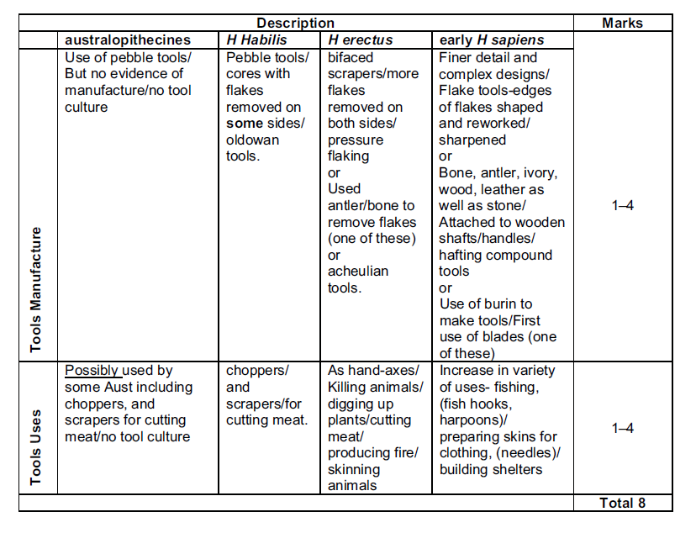

1. Changing lifestyles.

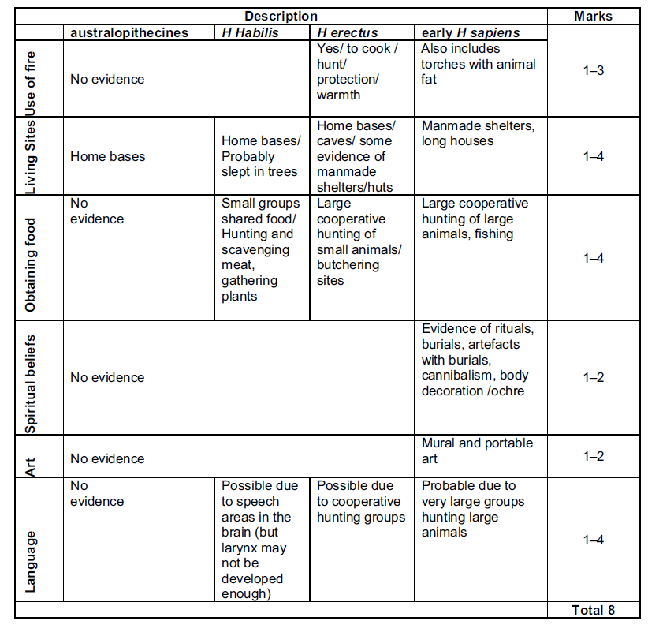

1. The evolution of the Australopithecines into Homo can be related to certain physical advances that improved their survival chances. Describe four physical changes that have characterized hominin evolution, and explain how these advances aided survival. (4 marks)

|  |  |  |
| --- | --- | --- |
| **Physical change Description** | **Aided survival**  **(any reasonable answer)** | **Max 4 marks**  (mark awarded when linking physical change to survival) |
| Skeleton:  Position of foramen magnum/curvature of spine/jaw/pelvis/carrying angles/knee/foot/center of gravity | Structures associated with bipedalism allowed hominins to cross open ground | 1 |
| Upright stance:  Stature became taller/more upright | * Increased range of vision * Increased stance🡪size appearance to deter predators * Free hands for carrying food/tools * Further/higher reach for food * Thermodynamics | 1 |
| Size of cerebral cortex: Brain size increased (approx. 450 to 800 cc) | * Increased muscle control, ↑ problem solving ability | 1 |
| Prognathism:  Face shape became flatter; size of Jaw reduced | * Survival in cold and dry environments with wider noses | 1 |
| Dentition:  Size of teeth reduced | * Diet – move into carnivore diet/seasonal changes | 1 |

**In class validation**

**Answers**

1. A near-complete fossil skeleton was recently discovered in the Olduvai region of East Africa. Initial anatomical analyses suggest that the fossilised skeleton is that of a *Homo habilis*. This identification is further supported by its dating to 1.8 million years before present. **(10 marks)**
   1. Describe the likely anatomical features of the fossilised skeleton is that lead to the conclusion it was *Homo habilis* and not some other species. (5 marks)

**Any 5 of the following points for 5 marks:**

* Features are generally midway between Australopithecines and modern humans
* Larger brain
* Smaller teeth
* Narrow face
* Small brow ridge (compared to Australopithecines)
* Relatively long arms
* Small body size relative to modern humans
* Hand structure slightly more robust
  1. Tools consistent with Homo habilis were also found in the vicinity of the fossilized skeleton. Describe the tool culture associated with *Homo habilis*; include in your answer what these tools may have looked like and how their use reflected the lifestyle assumed for *Homo habilis*. (5 marks)

**Any 5 of the following points for 5 marks:**

* Simple/primitive/crude tools
* Flake tools
* Cores or choppers
* Made of stone/pebble tools, or of Oldowan style, chert/flint/volcanic glass
* Reflected lifestyle of meat eaters
* Tools enabled H. Habilis to cut open prey/obtain flesh
* Tools too simplistic to reflect hunting lifestyle
* Lived off kills of other animals and scavenged

1. Discuss how tools subsequently changed with the emergence of *Homo erectus* and *Homo neaderthalensis*. (10 marks)

***H. erectus***

**Any 5 of the following points for 5 marks, or reasonable answer:**

* Basic pebble/ Oldowan tools
* Pear shaped/teardrop shaped hand axes/Acheulian
* Flaked on both surfaces/coupe-de-poing
* Also borers/scrapers/blades
* Made of stone
* More complex compared to *H. Habilis*
* Tools used for killing and skinning of prey/or for making fire

***H. neanderthalensis***

**Any 5 of the following points for 5 marks, or reasonable answer:**

* Mousterian tools/flake tools/scrapers/points
* Tools had a specific purpose
* Many flakes made from core stone
* Flakes attached to wooden shafts/hafted tools
* Flakes with toothed/notched edges
* Tools used for building shelters/making clothes from animal skins/hunting